# Proposal

In the aftermath of natural disasters, images and stories of people struggling to survive flood our television screens, social media timelines, and radio stations. People often wonder how they can help – most give money to a charity of their choice, some volunteer to physically go and help with relief efforts. But what if they could help by contributing their knowledge? We are currently living in an era of unprecedented access to information. Anyone can find out what something is or how to do it – if they have the time to sift through the vast wealth of data. But in the aftermath of a disaster the one thing survivors often don’t have is time. And in a survival situation, ignorance can be lethal. We want to create the most comprehensive and simplest to understand resource for people to learn to survive.

Our project, Polaris – named after the North Star, a navigation aid used for millennia to help those lost in the wilderness find their way back home – aims to create a database of user-generated and professionally vetted information on survival skills. Not only that, we want to create a database of user locations and information that can be used by relief crews to know where people need help and what kind of help they need.

The impetus for this project came about during the Atlantic hurricane season of 2017. After Hurricane Harvey flooded Houston, people used social media to broadcast medical emergency information so first responder crews could get to the correct places. And after a double blow from Hurricanes Irma and Maria, Puerto Rico’s infrastructure collapsed – no electricity but what portable generators could make, no running water, and numerous roads wiped away in the waters. The goal of Polaris is twofold:

1. We want to teach people how to help themselves in the immediate aftermath of disaster.
2. We want to set up an easy tracking system for relief crews to get people the help they cannot give themselves.

We will achieve these goals by having articles that anyone can search for and access, regardless of if they are an account holder or not. Users can also create an account to save articles to their profiles and download said articles in the event of a disaster warning. This way they can get the information even if internet access is knocked out. The articles will be saved in a PDF format meaning that each and every one can be printed out into a hardcopy if the threat of power loss is predicted. If they want to write articles, they must sign up for an account and be willing to have each article vetted and passed through an editing process to ensure information accuracy. To sign up for the emergency locator service, they have to make an account and put in their location. The account information can be shared with one or more family members/friends – this ensures that even if your cell/internet service is knocked out, a trusted individual can update your information for you so that emergency crews can remain appraised of your status.

## Breakdown of Roles

|  |  |
| --- | --- |
| Renee Geffre | * Database developer * PDF conversion * PDF viewer integration |
| Michael Kallgren | * Map API Integration * Weather API Integration * Documentation * Assist in development of UI forms. |
| David Goodrich | * Server Routing * Front-End Development * User authentication/authorization |
| Brian Martin | * Front-End Development * UX/UI * Page Component Design and Lead |

## Task Schedule

## User & Data Flow Chart

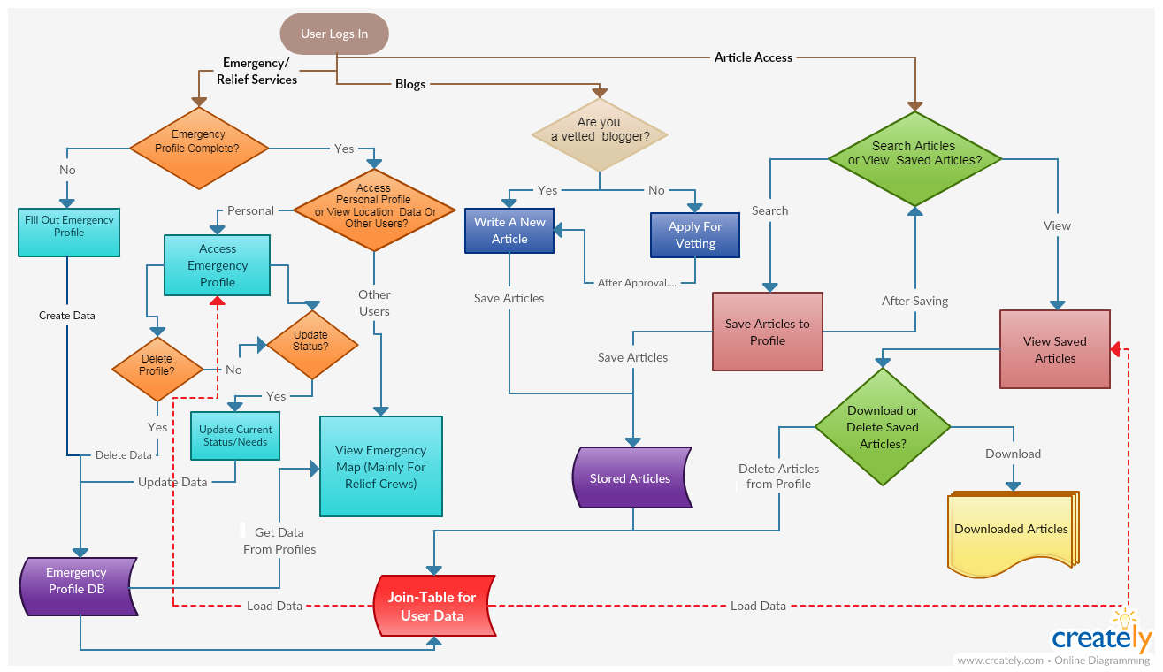

aaa